**Assignment 3: Movie Database**

Please find below three implementations in Movie. Scala (lines 109, 134, 215) and one in IngestSpec.scala (line 23).

**Line number – 109**

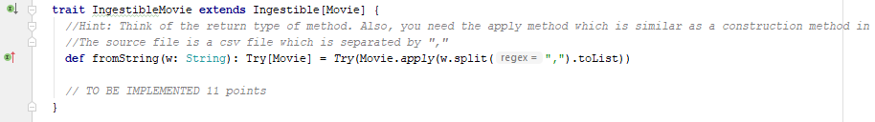

**Line – 134**

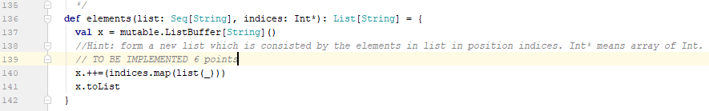

**Line – 215**

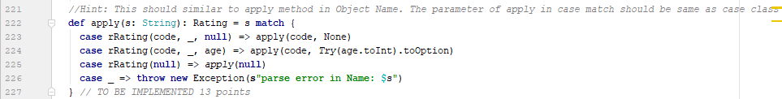

**Line – 23**

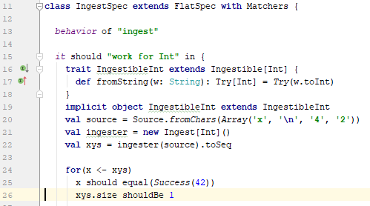

**Below is the screenshot of test cases passed:**

